
Department of Mechanical Engineering

EMCH 368
MECHATRONICS

Lab 07
PCB Design

Created by C. Smith – Aug 15, 2021
Last Edited by Tyler Russo – June 17, 2024


KiCad is an open-sourced electronic design automation suite used to create and design printed circuit boards (PCBs). PCBs are an alternative to the prototyping breadboards you have been using in this class and are used to create compact circuitry for a more developed product. For example, your computer’s graphics card and hard drive are contained on PCBs rather than breadboards to reduce space and ensure reliable connections. The Arduino Uno itself is contained on a PCB (see the layout in Figure 1).

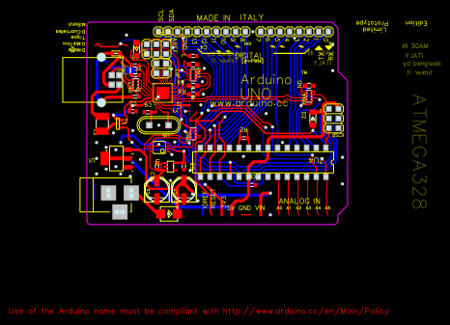
Figure 1: Arduino UNO R3 PCB layout.

In this lab, you will be using KiCad to create a PCB for a fading LED circuit. The circuit is relatively simple and utilizes a voltage source (in this case an Arduino Uno), a capacitor, two resistors, and an LED. The schematic for the circuit is shown in Figure 2.
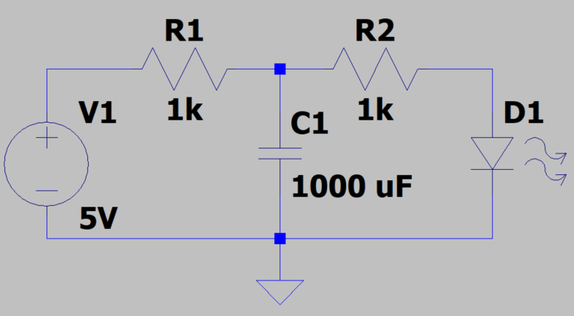
Figure 2: Schematic of a fading LED circuit.

The circuit works by using a 5V source to both light up the LED and charge the capacitor (remember, a capacitor stores voltage to supplement drops in the primary voltage source). When the 5V source is removed, the capacitor acts as a voltage source to continue to power the LED until its charge decays, creating a fading effect on the LED. Figure 3 shows the exponential decay of the voltage as the capacitor drains once the 5V Arduino power is removed. The purpose of R1 is to prevent a short circuit between the voltage source and the capacitor, and the purpose of R2 is to be a current limiting resistor when the Arduino voltage source is removed and the capacitor takes over as the voltage source powering the LED.


Figure 3: Discharge of the capacitor in the absence of the Arduino 5V.

To begin, you must first download the KiCad software onto your device.

Access instructions:
- Go to https://www.kicad.org/ and click the blue download button and follow the instructions to install KiCad for your operating system.
- Additional resources on how to install KiCad for different OS can be found here.
- Ensure the Arduino IDE is already installed. Go to https://www.arduino.cc/en/software to download if it is not already installed.
- That’s it!

Part One: Designing a PCB in KiCad

In this section, you will use the KiCad software you just downloaded to create a printed circuit board for the fading LED circuit.

Creating the schematic

- Open KiCad go to File > New > Project and create a new project entitled fading_led.pro.
- You will notice that creating a new project automatically creates a fading_led.kicad_pcb
and a fading_led.sch file. These files house your PCB design and schematic, respectively.
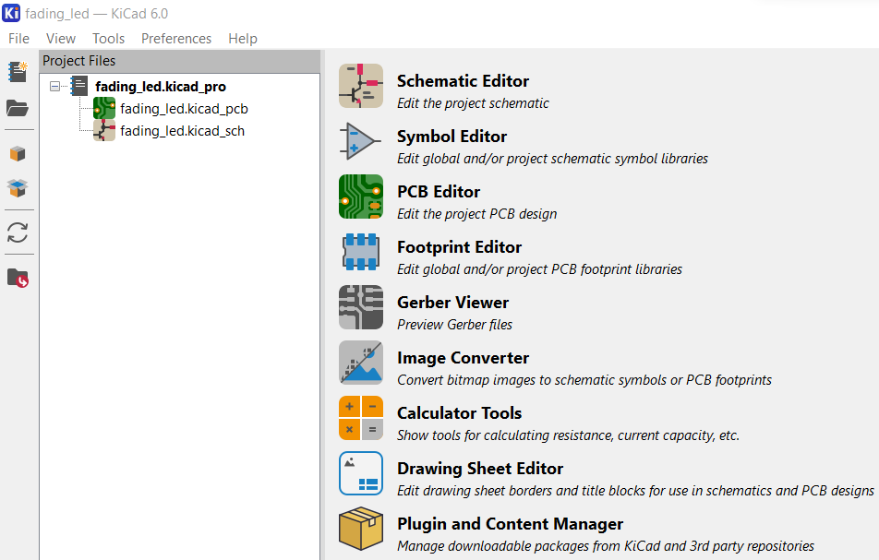
- KiCad is not just one software, but many softwares used for PCB design packaged together. To create schematics, Eeschema is used. To design the PCB layout, Pcbnew is used.
- First you need to design your schematic. Double click on the fading_led.sch file in the tree to open the Eeschema program.
- This is the environment KiCad uses to draw the schematic for your PCB. To add components, you will click the triangle on the right side of the screen that says Place Symbol. This will open the Choose Symbol dialog box.
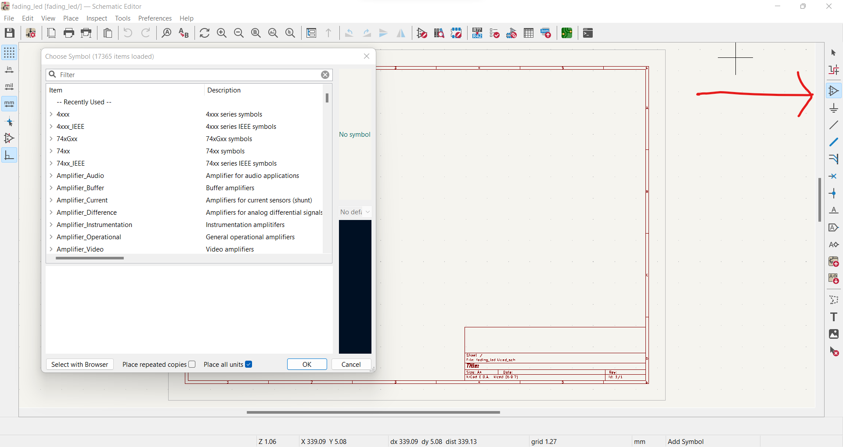
- You can search for the KiCad symbols at the top. Build the schematic according to Figure 2 but replace the voltage source with a connector for the Arduino. Table 1 has suggestions for each symbol, but feel free to customize the sizes and connectors.

Table 1. Schematic symbols and their KiCad equivalents.
Schematic symbol | KiCad symbol
Voltage source | Screw_terminal_01x02
R1 | R
R2 | R
C1 | C
D1 | LED
Ground | GND

- To move symbols around, click on the symbol and press the M key. To rotate symbols, click on the symbol and press the R key.
- Once you have all the symbols laid down, use the black Place Wire option to build connections between the symbols according to Figure 2.
- To create a common ground for each component, click the Place Power Port  option. Click on the Eeschema canvas and search for GND in the dialog box to place a ground symbol.
- Your schematic should look like the one below:
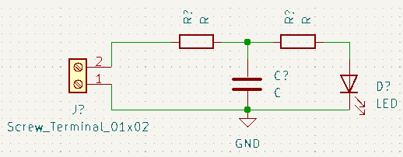

- Before you can send your schematic to Pcbnew to design your PCB layout, you need to do a few tasks. At the top of the toolbar, there are four buttons in succession you must go through:

- Begin with the Fill in schematic symbol reference designators button . Click on the button, then click “Annotate”, then “Close”. This button assigns each symbol a unique name. For example, the two resistors R? and R? became R1 and R2.
- Next, use the Electrical Rules Checker . Click on the button, then click “Run” to show any problems with how the schematic was wired. This is used for troubleshooting to ensure that wires were properly placed and follow circuit logic. In the sample schematic above, the only message that pops up is shown below. This however is fine, since the screw terminal will connect an Arduino that will drive the power pins in the circuit.
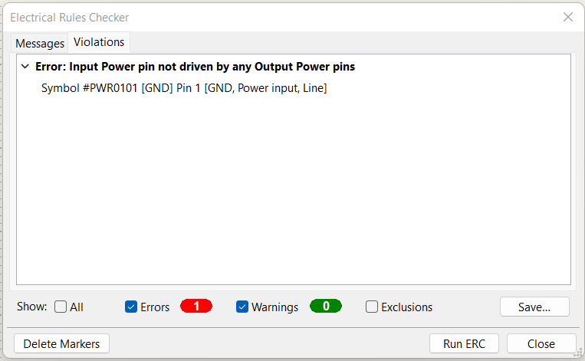

- Close out of the Electrical Rules Checker and use the Assign PCB Footprints to Schematic Symbols button . This is where the schematic symbols will each be represented by a specific footprint. Footprints are the physical space on a PCB board that are used to solder components onto the board. For example, a resistor footprint will have the same dimensions as a real-life resistor, along with two copper contact points on which to solder the resistor.

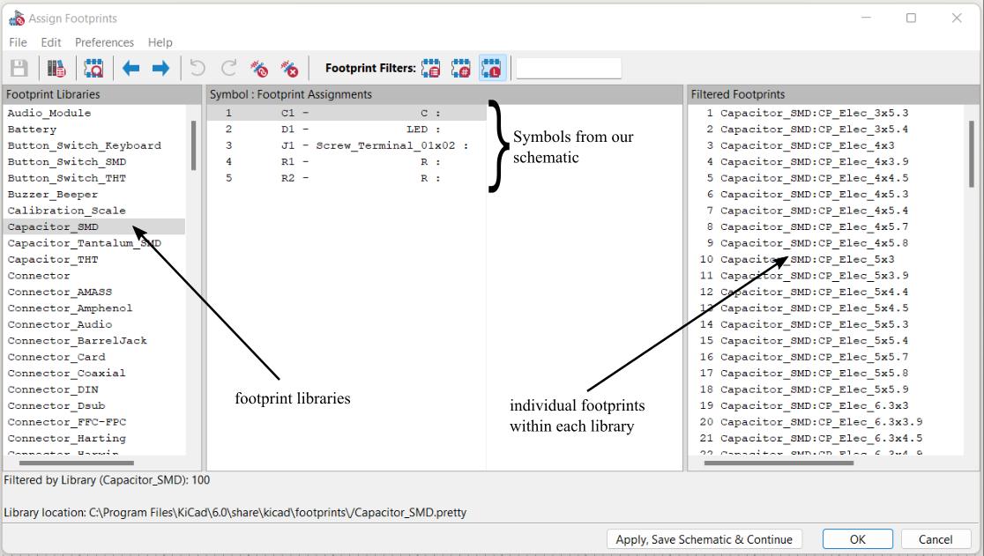

- The footprint assigner goes through each symbol in the schematic to assign each a footprint. To choose a footprint, make sure the desired symbol is selected in the middle pane, single-click the proper footprint library in the left pane, then finally double-click the correct footprint in the right pane. You should see the footprint name pop up in the middle pane next to the schematic symbol. Table 2 shows the footprints assigned for each symbol.

Table 2. Schematic symbols and their corresponding footprints.
Symbol | Footprint library | Footprint
C1 | Capacitor_SMD | CP_Elec_8x10
D1 | LED_THT | LED_D3.0mm
J1 | TerminalBlock_Phoenix | TerminalBlock_Phoenix_MKDS-1, 5-2-5.08_1x02_P5.08mm_Horizontal
R1 | Resistor_SMD | R_1812_4532Metric
R2 | Resistor_SMD | R_1812_4532Metric

- Click “OK” to close the footprint assigner and click on the Open PCB in board editor button to open the PCB editing software Pcbnew.

Creating the PCB
- Click on the Update PCB with changes made to schematic  button, then click “Update PCB”. The footprints should show up in the workspace, connected by white lines that indicate electrical connections.
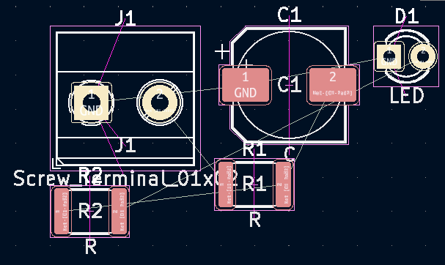

- Pcbnew allows you to edit by the layer. The Layers Manager is in the right hand pane of the workspace, and the current layer is indicated by the blue triangle . The layers you will be editing in this project are the front copper (F.Cu), back copper (B.Cu), and Edge.Cuts.
- Begin by drawing the outline of the board. Change to the Edge.Cuts layer by clicking the light grey square by the layer name in the Layers Manager pane. Using the Add Graphic Lines button , draw a 25.4 mm by 25.4 mm square to be the outline of your PCB. The default spacing of the grid is 0.254 mm apart.
- After building the board outline, arrange the footprints in a logical manner. You can move/rotate footprints by clicking on the desired footprint and pressing the M/R keys. Some things to keep in mind when laying out the footprints:
  - The screw terminal needs space for the Arduino leads to plug into
  - The white lines (called ratsnest) indicate places where electrical connections will be made between footprints (ex. The white line that connects one pad of R1 to one pad of R2 show where a wire will be drawn)
  - The yellow pads are through-hole (THT) connections, meaning there is a copper hole drilled into the PCB for components. The red pads are surface mount (SMD) connections meaning the copper connection is exposed only on one side of the PCB.
  - An example configuration is shown below:
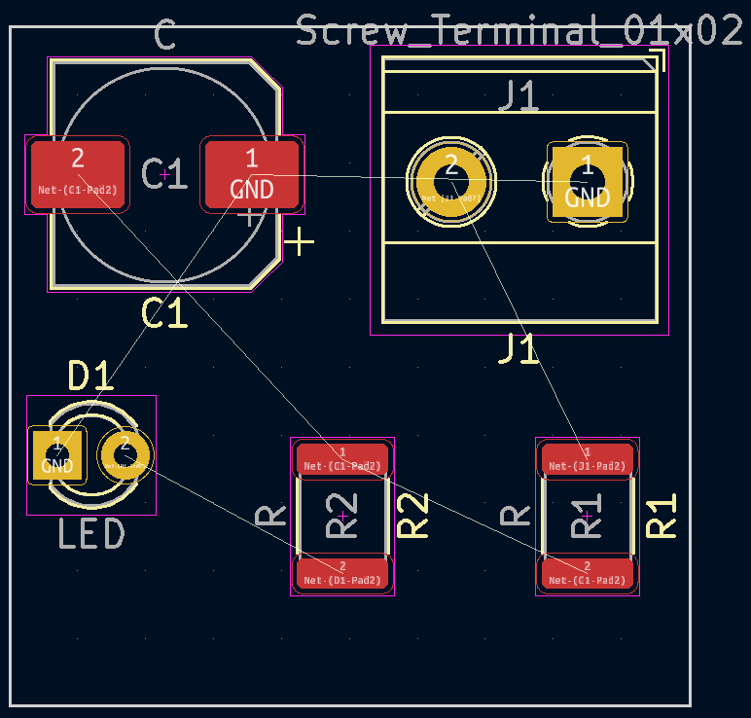

- Now that the components are laid out, it is time to make the wires. Ensuring that you are on the F.Cu layer, click the Route Tracks button  and begin drawing the connections between pads. Do this for all connections EXCEPT for all ground (GND) pads.

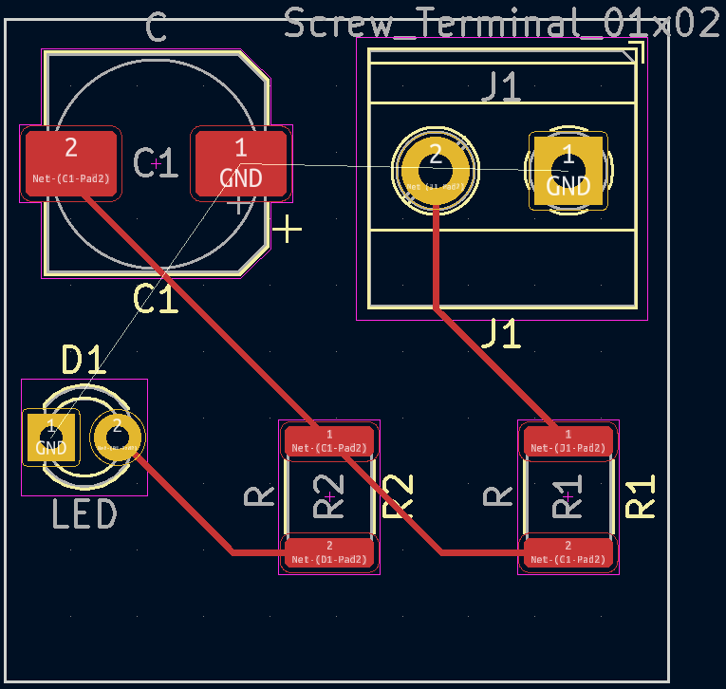
- In order to ensure the Arduino, capacitor, and led all have the same ground connection, you are going to make a ground layer. A ground layer is a layer of pure copper laid into a PCB that acts provides a common ground for every grounded component on a board. This prevents floating grounds, which can damage electronics.
- Begin by clicking the Add Filled Zones button  and click on one of the corners of the board outline. A Copper Zone Properties dialog box will pop up prompting you to choose a layer and a net. The net refers to which pads you want the filled zone to connect to. In this case, since you are creating a ground layer, choose the GND net. Ensure the F.Cu layer is selected since all of your SMD components are grounded on the front copper layer.

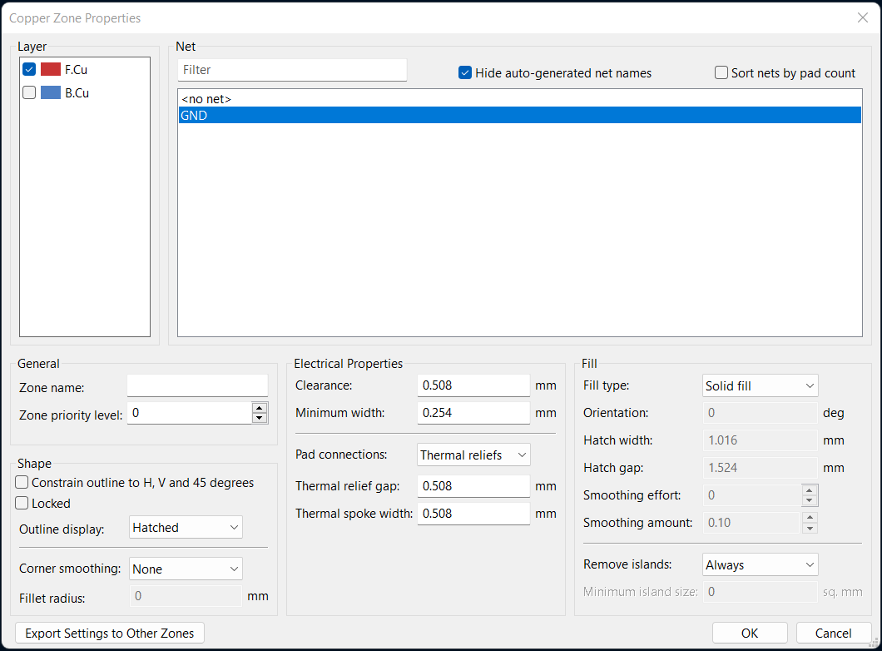

- After clicking OK, proceed to outline the board with the cursor to define the zone. After closing the outline, right click and mouse over the Zones option and click on Fill All to fill the copper zone you just created.
- Click on the Show filled areas of zones button on the left hand toolbar to see the grounding layer you just created. Notice how the zone connects to all the GND pads but leaves space around the copper traces and non-GND pads.

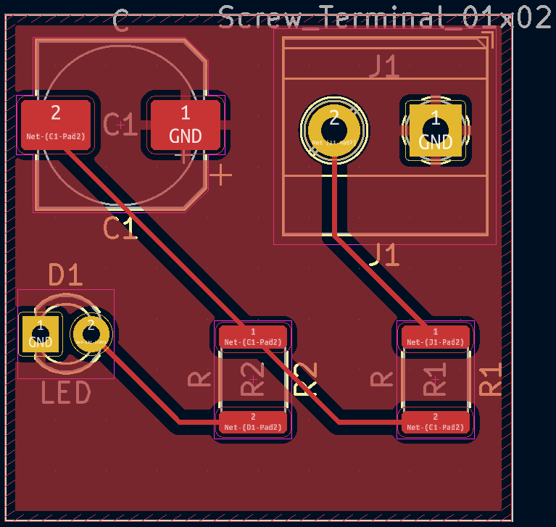

- You can proceed to repeat steps 23-25 with the B.Cu layer. Two grounding planes are used in complex PCBs as they often have surface mount components on both the front and back copper layers that need to have a common ground, and thus require two ground planes. However, as all the components on this PCB are on the F.Cu layer, such a measure is superfluous.
- Once you’ve created the grounding layers, you’re done! You can go to View > 3D Viewer to see a 3D model of your PCB design.

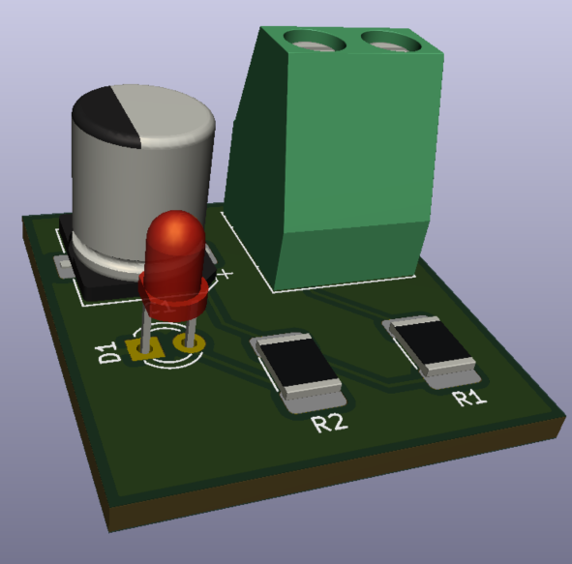

- Have the TA check off your design.

Part Two: Soldering
In this section, you will be soldering the circuit of the PCB you just created. Soldering is the act of creating electrical connections by melting a conductive metal between the PCB and components. Think of it as an electronics version of welding. The solder, which is typically a mixture of metals with low melting points (such as tin and lead), is heated up with an iron along with the copper points of connection and creates a bond between the two points of connection.
Surface mount components are soldered differently than through hole components. In this lab, you will learn how to solder both types of components. The table below shows the different components and their labels on the PCB.

Table 3. PCB labels and their components
Component | PCB Label | Connection type
Screw terminal | +/- | Through hole
2k resistor | R1 | Surface mount
2k resistor | R2 | Surface mount
1000 uF capacitor | C1 | Surface mount
LED | LED | Through hole

- Begin by familiarizing yourself with the components at your station:
  - PCB – this is what you will be soldering onto
  - Solder – this is the metal you will melt to create connections
  - Soldering iron – this is what you use to heat up the solder and contact points
  - SMD components – these are the resistors and capacitor that you will solder onto the surface mount pads of the PCB (recall, the SMD connections are the copper squares on one side of the board)
  - THT components – these are the screw terminal and LED that you will solder into the through hole pads of the PCB (recall, the THT connections are the copper holes that go through both layers)
  - Helping hands – these are used to hold the PCB while soldering
  - Tweezers – these are used to hold components steady when soldering
- Arrange the helping hands to hold the PCB in place.
- To solder, first begin by turning on the soldering iron to 750F. Temperature requirements will vary depending on the chemical makeup of your solder. Figure 4 outlines the process of soldering SMD components. Be sure to thoroughly read steps 4-8, as soldering needs to be a relatively swift process.
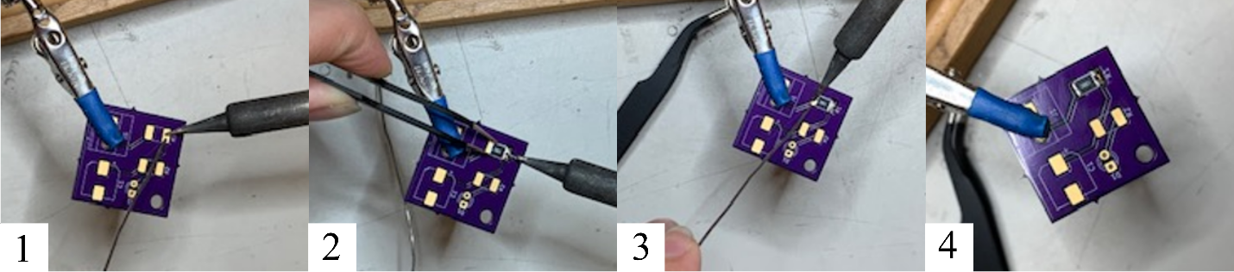
- Once the iron is heated up, you will solder the 2k ohm resistor to the R1 footprint. Find the corresponding footprint and melt solder onto one of the pads. You will see a plume of smoke, that is the flux of the solder burning away and allowing it to become shiny and melt. Remove the iron and allow the solder to cool. Solder solidifies at room temperature in seconds. Some things to consider:
- You will feel the entire PCB get warm
  - Do not heat the copper pad for too long as it can damage the PCB, especially if the iron slips and heats the purple finish.
  - Again, the solder solidifies quickly at room temperature so do not be too afraid of touching the component after soldering.
- After melting the solder onto the pad, use the tweezers to place the resistor over the footprint, pressing one end against the solidified solder. Use the soldering iron to heat up both the metal end of the resistor and the solder. The solder should melt again and cover the end of the resistor. Remove the iron and ensure the resistor is fixed to the PCB.
- Use the iron to heat up the second end of the resistor and the second pad, then apply solder to fix the second end of the resistor to the pad. The resistor should be fully connected to the PCB now.
- Repeat the process with the rest of the SMD components. Be sure to note the polarity of the capacitor: the black strip is the negative side, which should be closest to the edge of the PCB.
- Once all the SMD components are soldered, you will solder the through hole components consisting of the LED and screw terminal. These differ from the SMD components in that the component is placed through the hole rather than on top of the copper.
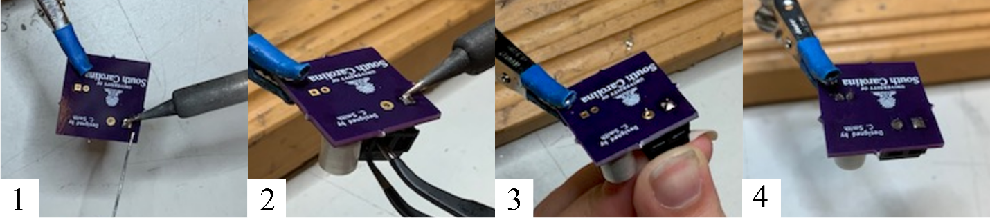
- Flip the PCB over and apply solder to one of the two pads of the footprint, without the screw terminal in the hole.
- Use the tweezers to hold the screw terminal against the two through holes. Ensure the terminal is properly oriented, with the wire connectors facing outwards. Use the soldering iron to remelt the solder, then push the pins of the screw terminal through the hole.
- Remove the iron and allow the solder to cool, bonding the terminal to the PCB. Do not let go of the screw terminal until the solder has cooled.
- Heat up the unsoldered pin of the screw terminal and apply solder to ensure a solid connection.
- Repeat the process with the other through hole components.
- Once you finish soldering everything, turn off the soldering iron and fan.

Part Three: Programming the Arduino
- The code for the Arduino is quite simple. In the Arduino IDE, open the Blink sketch under File > Examples > 01.Basics > Blink.
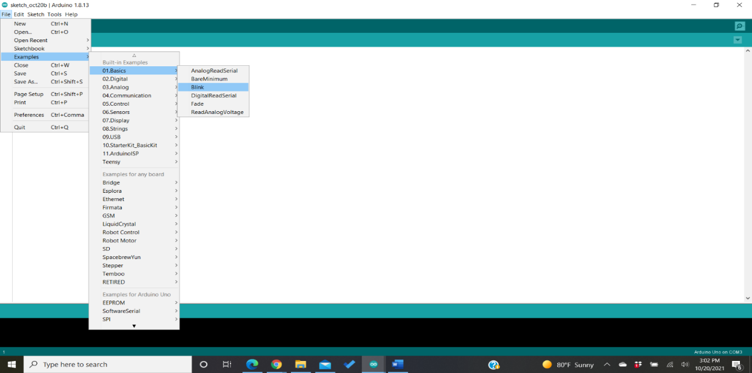
- In the example, change the delay from 1000 ms to 1500 ms. This is to ensure we can fully charge and discharge the capacitor, and hence see the full effect of the fading LED.
- Use two jumper wires to connect GND and D13 to the screw terminal of the PCB. Look closely at the screw terminal footprint to see which is the + and – side.
- Upload the code to your Arduino. You should see the LED fade on and off every 1.5 seconds.

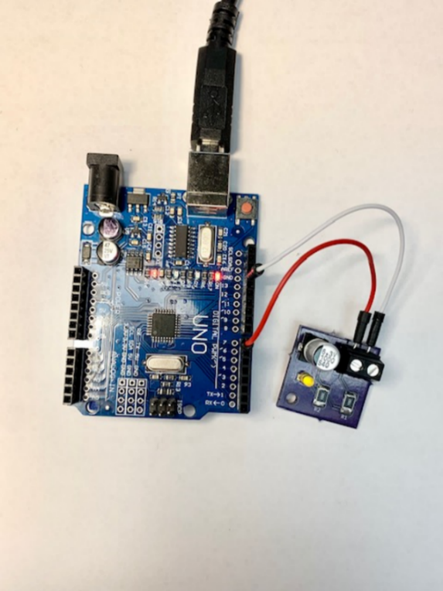

Power Source Introduction:
In any mechatronics lab, understanding power sources is crucial for the proper functioning of electronic circuits. The primary types of power sources you'll encounter are batteries, DC power supplies, and AC power supplies.
Batteries are portable power sources that provide a fixed DC voltage, such as AA batteries or lithium-ion batteries. They are convenient for small, portable devices but have limitations in capacity and fixed voltage output.
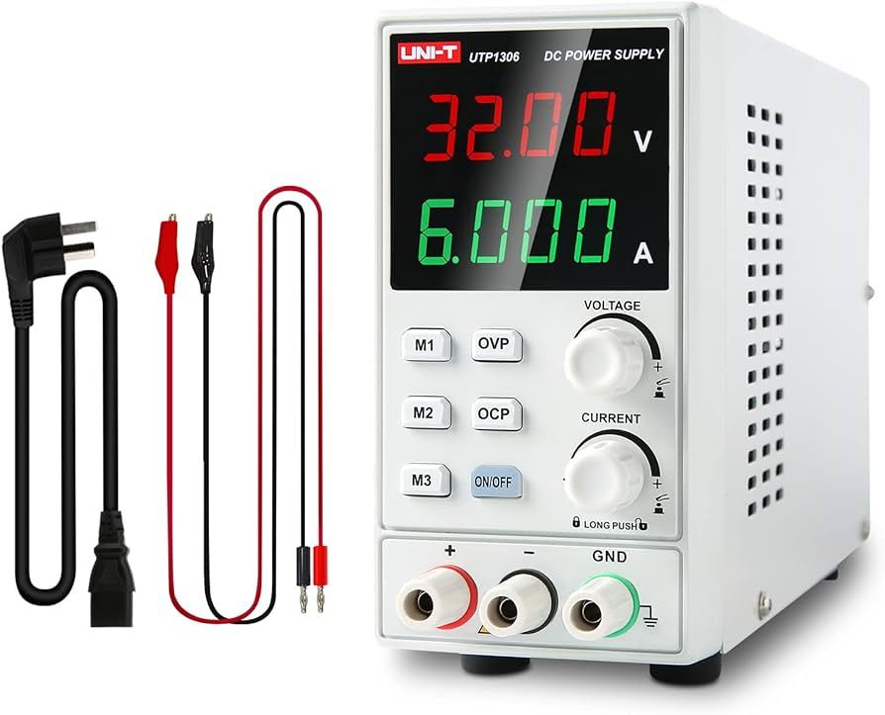
DC power supplies are more precise and adjustable, making them ideal for lab use. They provide stable and adjustable voltage and current, allowing you to match the exact requirements of your circuit. This flexibility is critical for safe and effective testing and development.
A common tool in labs is the bench power supply. This device offers controlled DC voltage and current with features like adjustable settings and digital displays. To use it, set the desired voltage and current, connect the leads to your circuit, and power it on. The display helps you monitor the output to ensure everything is as expected.

AC power supplies are used to provide alternating current, often necessary for devices that run on AC or for converting AC to DC using rectifiers. They are less common for simple circuit testing but essential for certain applications.
In summary, batteries offer simple, portable power, while DC power supplies, especially bench power supplies, provide the precision needed for lab work. AC power supplies cater to specific needs.

Lab Grading Rubric:
- Present your PCB design (15 Points)
- Present soldered example PCB (15 Points)
- Present example PCB with Arduino (10 Points)
- Comprehension Questions (10 points)

